**Dimension(EON) | Progress Report — November 2019**

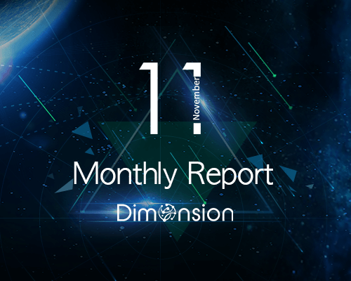

**Technical Progress**

**1. Internal Test Network Test Run**

Passed the test of the pledge ticket exchange mechanism

Three types of consensus algorithms for hybrid consensus HPoS-P have been verified

BUG fix: new block nodes do not generate blocks in special scenarios

**2. Dynamic Node Testing**

Newly added node pledge becomes governance node

New governance node successfully launches proposal

Governance node switches to ordinary node after redemption and pledge

**3. Cross Consensus Engine Testing**

After the proposal is passed, the network will stabilize the block according to the new consensus

Optimize consensus switching interface

Fix bug in parameter passing

**4. Hybrid consensus test**

Complete hybrid consensus HPoS-P three types of consensus algorithms

Consensus Algorithm A: DPoS + PBFT (2/3 + 1)

Consensus Algorithm B: DPoS + PBFT (1/2 + 1)

Consensus Algorithm C: DPoS + PBFT (1/3 + 1)

**5. Middleware Framework X-GEN**

Developed middleware payment module DimPay

Develop external unified account access module

Develop whitelist access mechanisms